**Set by:** Mike Sanderson

## **Credit**: 10% of total module mark

**Deadline:** 11.59.59, Wednesday 16 February

# Introduction

The assignment comprises three independent exercises. They are not equally weighted.

You should refer to the Undergraduate Students’ Handbook for details of the University policy regarding late submission and plagiarism; the work handed in must be entirely your own.

It is expected that marking of the assignments will be completed by the beginning of week 24.

You may if you wish, use jQuery, but are not required to do so.

# Submission and Marking Criteria

Copies of all code (including CSS, JavaScript, and HTML files) must be submitted to FASER by the deadline in a single .zip or .7z file. (Marks may be deducted for files submitted in any other format.)

Other than where specific instructions have been given about coding (e.g., the use of an array of objects in exercise 2) the only criteria to be used for marking of this assignment are that the web pages have the correct functionality, and, where appropriate, the required style.

# Exercise 1 – Dynamic Data Table [35%]

The requirement for this exercise is to use JavaScript (together with CSS and HTML) to produce a dynamic table of data listing conversion temperatures in degrees Celsius and degrees Fahrenheit.

The web page must obtain from the user the range (in Fahrenheit or Celsius) of the temperatures to be displayed and produce a table showing each temperature in the range alongside its equivalent in the other unit, which must be displayed to ***exactly two decimal places***.

The user must be able to select whether the conversion is from Celsius to Fahrenheit or from Fahrenheit to Celsius. The JavaScript may be invoked by a button-click or a menu selection.

Table header cells must have a background color that differ from data calls; alternative rows must have different text colors.

Text box input fields should be used for the entry values for the start and end of the range. The user must supply at least one value; he or she may leave the second field empty.

Validation must be performed – the first value supplied by the user must be an integer and the other (if supplied) must also be an integer.

An alert or error message should be displayed if the validation fails.

(If the user enters a number that is not an integer you may either reject it or warn the user that the input has been truncated/rounded to an integer).

Negative inputs should be allowed.

The user may enter the two values in either order so the program should be capable of displaying the table in ascending and descending order.

If only the first value is supplied, you should use a range of values from 5 less than the value supplied to 5 greater than the value supplied for the other value.

You should reject the inputs if the difference between the two values is unreasonably large.

(You should use your own judgement to decide what is meant by “unreasonably large” but must not reject differences of less than 25.)

# Exercise 2 – Marking Form [30%]

This exercise requires the creation of a marking form for an assignment.

Your solution should have components as shown below and display the total mark, which should be updated as marks are entered or changed.

The form must be created using JavaScript.

The details of sections (i.e., their names and maximum marks) must be stored in an array of objects (which must not themselves be arrays) so that it is easy to change these details by changing the initialization of the array in one place in the JavaScript file.

all the HTML-generation code must obtain the necessary data from the array.

You should ***not*** assume that the array will always contain details of exactly five sections or that the maximum marks will always total 100.

Each drop-down menu should contain all the integers from 0 to the maximum mark for the section.

The form should have a Clear button, which when clicked, should clear all the comments, and reset all marks to 0.

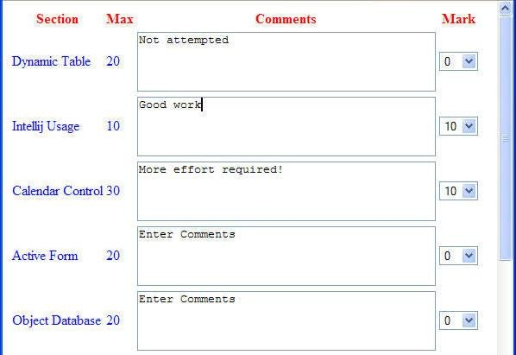

# Exercise 3 – Word Count [35%]

The requirement for this exercise is to write JavaScript code to extract the text from an external HTML page and count the number of occurrences of each word in the text.

The results should be presented in a table displaying each word and its number of occurrences.

To gain more than 25 of the 35 available marks the code should be capable of displaying the results in alphabetical order and in order of frequency, with the user able to select which is used.

You may, if you wish, assume that the web page is on the same file system as the web page written for the exercise, to allow the technique in lab 3 to be used to extract the contents of the page. You may also assume that the web page comprises correctly formed XHTML.

The user must be able to select what HTML file is to be used; this may be done in any sensible way

A word is to be regarded as any sequence of non-white-space characters within a text node within the body of the document so in the following simple web page the words are Hello, World! Click, here, and Goodbye (with World! having two occurrences).

Words are to be regarded as case-insensitive so World! and world! should be viewed as occurrences of the same word.

(Words within tags, such as body and href in the example below, should not be included in the count.)

<html>

<body>

<p> Hello World! <br/>

<a href = ”link.html”> Click <b> here </b> </a> <br/>

Goodbye world!

</p>

</body>

</html>